Cameroonian Recipes

By Elder Hanna

4/11/2019

Douala, Cameroon

If using dry bitter leaves soak overnight and cook for 15 minutes using 1 teaspoon of bicarbonate soda. Rinse thoroughly and drain.

<https://www.preciouscore.com/how-to-make-lovely-ndole>

I love making my Ndole with beef or beef feet (foot cow) but this time I had just stock fish at home and I wasn’t about to take a 20 minute trip to a store to get my choice meat. Like they say, use what you have to get what you want. Since I had stock fish at home so I decided to add shrimps to it in order to make it a seafood version of the meal. Absolutely ah-mazing! If you are not a fan of shrimps, seafood and other things like that please just use regular meat. It works just fine.

**NDOLE RECIPE**

*Prep time: 30 minutes*

*Cook time: 30 minutes*

*Total time: 1 hour*

*Serves: 4-6*

You’ll need

2 cups of peeled groundnuts (also called called peanuts)

3 cups of bitterleaf and/or spinach

Half teaspoon of baking SODA (for blanching vegetables)

1/4 cup crayfish- coarsely blended

2 pounds of boiled beef/beef feet/smoked fish/stock fish/shrimps

5 cloves of garlic

1 inch of ginger

1 maggi crevette (crayfish seasoning cube)

2 regular seasoning cubes (maggi or knorr)

1 large onion

1 cup of vegetable oil

1 habanero pepper (totally optional)

**Here is how to make lovely Ndole**

I used a blend of dried bitterleaves and fresh spinach so I started out by soaking my bitterleaf. So soak your bitterleaf if dried before blanching. If using fresh bitterleaf, skip this stage.

[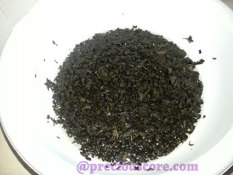](https://www.preciouscore.com/wp-content/uploads/2016/02/bitter2Bleaf.jpg)

Put your groundnuts in a pot and let it boil. I purchase already peeled groundnuts from the store. When boiling, put just enough water to slightly cook the groundnuts so you do not have to throw any.

[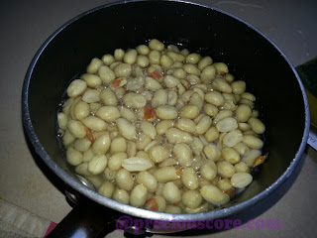](https://www.preciouscore.com/wp-content/uploads/2016/02/skinless2BGroundnut.jpg)

Here are the cooked groundnuts with very little water left which I used in the blending process.

[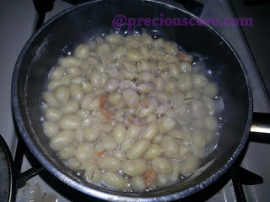](https://www.preciouscore.com/wp-content/uploads/2016/02/boiled2Bpeanuts.jpg)

If using shrimps, season them with a little salt (and white pepper if you wish) and set aside to marinate.

Chop up your spinach.

[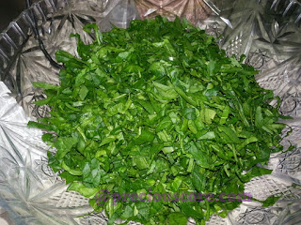](https://www.preciouscore.com/wp-content/uploads/2016/02/chopped2Bspinach.jpg)

Start the boiling and blanching process. Put water in a pot to boil and put in salt and baking soda. The baking soda helps the vegetables retain their green colour just like “Akangwa” or “Kangwa” (lime stone). However, I have read that baking soda may harm some nutrients in vegetables so if that is a concern to you, you may want to skip that. When water is boiled, put in bitterleaf and stir. The baking soda of kangwa causes it to foam.

[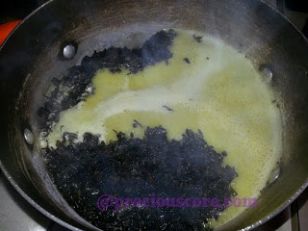](https://www.preciouscore.com/wp-content/uploads/2016/02/boil2Bdry2Bbitterleaf.jpg)

Use the tip of your finger to check the bitterleaf for softness.

[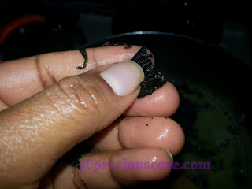](https://www.preciouscore.com/wp-content/uploads/2016/02/test2Bdry2Bbitterleaf.jpg)

If soft enough, add in the spinach and turn off the stove. Let it sit for TWO minutes. If you leave the spinach in there for too long, it will get too soft and you may not like it. So two minutes it is. Look at that contrast in colour between the dried bitterleaf and fresh spinach!

[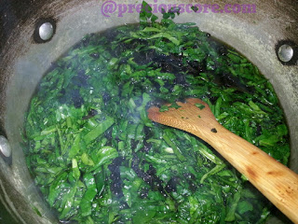](https://www.preciouscore.com/wp-content/uploads/2016/02/dey2Bbitterleaf2Band2Bspinach.jpg)

Pour vegetable onto a strainer and immediately run cold water on it. If you do not do this, the heat will continue to cook the vegetables much to your disadvantage. When you have rinsed thoroughly, use both hands to roughly kill the vegetables then you squeeze and keep in a bowl. Note: slightly more vegetable than the amount below made it to the pot.

[](https://www.preciouscore.com/wp-content/uploads/2016/02/marriage.jpg)

Peel garlic and ginger and chop half of your onions then put in a blender plus  your boiled groundnuts and pepper (if using). I used the small compartment of my blender because it does the job better for me. I had to blend the groundnuts in three batches.

[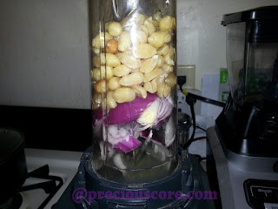](https://www.preciouscore.com/wp-content/uploads/2016/02/blend2Bpeanuts2Bfor2BNdole.jpg)

Blend that baby to perfection and by perfection I don’t mean a very smooth paste like pap. It should be SLIGHTLY rough like ground egusi mixed with water.

[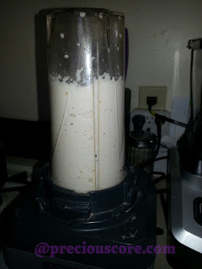](https://www.preciouscore.com/wp-content/uploads/2016/02/blended2Bpeanuts.jpg)

Haha! Good things are happening here. Go to the pot which contains your boiled meat and/or fish and its stock. Here is my pot of stock fish AKA stocky. When you love something so much, you give it a pet name. So for the love of stock fish, I named mine stocky. In Cameroon, stock fish is locally called, “Mukanjo.” Here is my pot of stocky (Oops! Looks like I already said that.)

[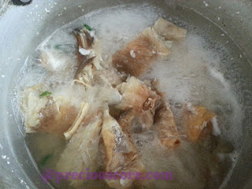](https://www.preciouscore.com/wp-content/uploads/2016/02/boiling2Bstock2Bfish.jpg)

Bring to boil then add your blended groundnuts and bring to boil. Let the aroma bless your home!

[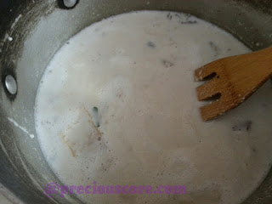](https://www.preciouscore.com/wp-content/uploads/2016/02/peanuts2Bfor2BNdole.jpg)

Add in crayfish and stir:

[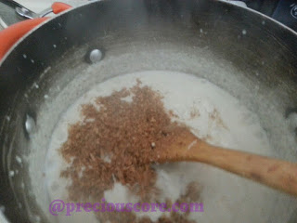](https://www.preciouscore.com/wp-content/uploads/2016/02/Ndole2Bcooking.jpg)

Then let the veggies go in.

[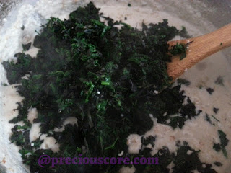](https://www.preciouscore.com/wp-content/uploads/2016/02/add2Bveggies2Bto2BNdole.jpg)

Give that a good mix, let it simmer for about 5 minutes and turn off the heat.

[](https://www.preciouscore.com/wp-content/uploads/2016/02/Ndole2Bmarriage.jpg)

Here is maggi crevette, the crayfish seasoning cube. I often add this to boost the flavour in dishes that have crayfish as an ingredient. So add in this baby and the other seasoning cubes. Taste to ensure seasoning is balanced.

Remember the left over half onion? Chop it up. Put oil to heat up in a skillet and saute the onions. Oh baby!

Add in the shrimps. Oh honey!

[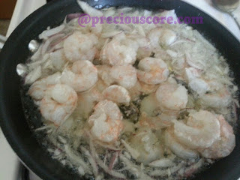](https://www.preciouscore.com/wp-content/uploads/2016/02/onions2Band2Bshrimp.jpg)

The shrimps are done when they turn pink. Add them to your pot of vegetable and groundnuts. Oh my!

[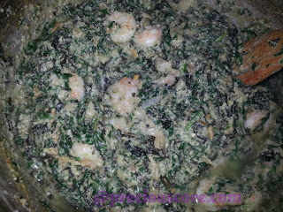](https://www.preciouscore.com/wp-content/uploads/2016/02/Ndole2Band2Bshrimp2Bonion2Bmarriage.jpg)

Serve with boiled plantains, boiled yams or miondo. You can even eat this deliciousness with boiled rice or garri. It is goooood!

[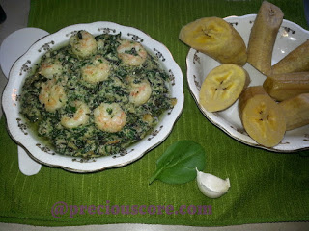](https://www.preciouscore.com/wp-content/uploads/2016/02/Ndole2Brecipe.jpg)

I had mine with ripe plantains. I was too impatient to let my plantains boil to perfection. That’s the power of Ndole!

**ERU RECIPE**

I’ll show you below how to make the perfect Eru everytime but first let’s look at some Eru don’ts:

-Don’t add water after adding in your Eru. It is a ‘dry soup’ You sure need water to cook your meat/fish but make sure the water is dried before you put in your spinach/waterleaf. The spinach will provide the moisture you need.

-Don’t add onions to Eru. I have seen some recipes including onions and that is just out of place. Original Eru needs no onions.

-Don’t cook Eru without crayfish. My Mom always says, “crayfish is the ingredient of Eru.” No amount of dried fish can replace crayfish in Eru.

-Don’t eat Eru with a spoon (okay, I’m kidding on this one!)

Let’s start cooking, people.

*Prep time: 30 minutes*

*Cooking time: 1 hour*

*Total time: 1 hour 30 minutes*

**Ingredients**

6 cups of Eru/Ukazi

3 bags/bundles of spinach/waterleaf

2-3 pounds of meat/fish of choice(beef skin/canda, beef stripes, beef, goat meat, dried/smoked fish, stocked fish, snails, and/or others)

2 cups of crayfish

3 cups of palm oil plus half cup of canola (or groundnut) oil

1 crayfish seasoning cube (Maggi Crevette)

1 Habanero pepper (optional)

Salt to taste

**Method**

If you are using dried Eru, start by soaking it in water.

[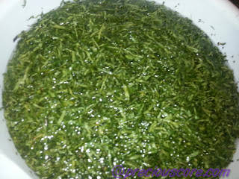](https://www.preciouscore.com/wp-content/uploads/2015/09/Soaked2BEru.jpg)

Wash your meat and put in the pot to boil. I used beef skin and beef stripes AKA *canda* and *towel.*

[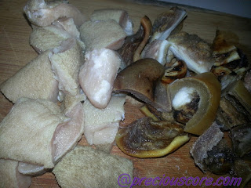](https://www.preciouscore.com/wp-content/uploads/2015/09/Beef2Bstripes2Band2Bbeef2Bskin-2Bcanda.jpg)

While the meat boils, chop your spinach or waterleaf and set aside.

[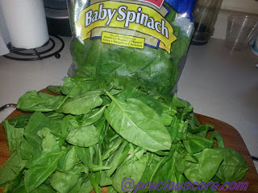](https://www.preciouscore.com/wp-content/uploads/2015/09/Spinach2Bfor2BEru2Bor2BAfang2Bsoup.jpg)

[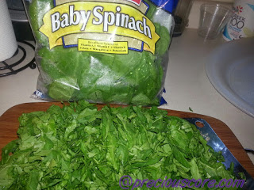](https://www.preciouscore.com/wp-content/uploads/2015/09/Baby2Bspinach2Bchopped.jpg)

When your meat is half-boiled, season with salt. When it is cooked, add in spinach and start stirring. Spinach is quite soft and will shrink fast as seen below.

[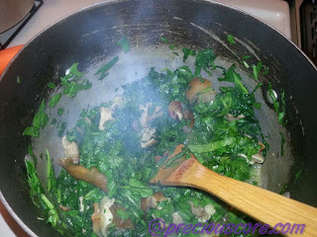](https://www.preciouscore.com/wp-content/uploads/2015/09/Eru2Brecipe.jpg)

Then you drain Eru and add to pot. The small liquid from the Spinach will make the Eru soft.

[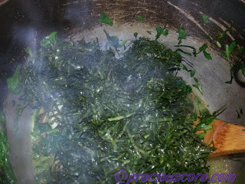](https://www.preciouscore.com/wp-content/uploads/2015/09/Cooking2BEru.jpg)

[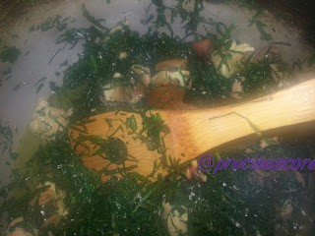](https://www.preciouscore.com/wp-content/uploads/2015/09/Cameroon2BEru.jpg)

Add in your fish and mix. I had some already boiled stock fish so I threw it in.

[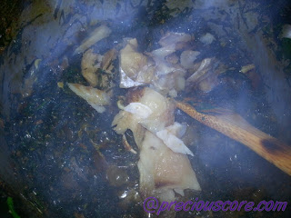](https://www.preciouscore.com/wp-content/uploads/2015/09/Stock2Bfish2BEru.jpg)

Then add the oil, seasoning cube and lastly crayfish. *Tip :*Mixing palm oil and canola/vegetable oil keeps the oil from becoming hard when the Eru is cold.

[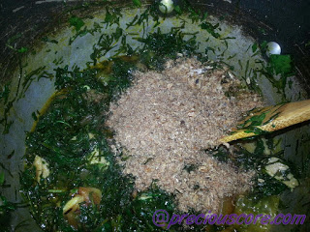](https://www.preciouscore.com/wp-content/uploads/2015/09/Crayfish2BEru.jpg)

Stir well and voila, Eru is ready. Serve with Water Fufu (Akpu), Garri or even Pounded Yam.

[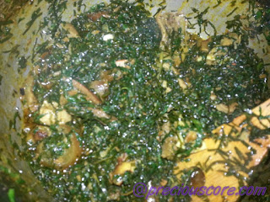](https://www.preciouscore.com/wp-content/uploads/2015/09/Delicious2BEru.jpg)

AUGUST 11, 2016

**CAMEROONIAN ROASTED FISH RECIPE**

**Sharing is caring!**

**130SHARES**

* [**Share**4](https://www.facebook.com/sharer/sharer.php?u=https%3A%2F%2Fwww.preciouscore.com%2Fcameroonian-roasted-fish-recipe%2F&t=CAMEROONIAN%20ROASTED%20FISH%20RECIPE)
* Pin it126
* [**Yum this**](https://www.yummly.com/urb/verify?url=https%3A%2F%2Fwww.preciouscore.com%2Fcameroonian-roasted-fish-recipe%2F&title=CAMEROONIAN%20ROASTED%20FISH%20RECIPE)
* [**Email**](mailto:?subject=CAMEROONIAN%20ROASTED%20FISH%20RECIPE&body=https%3A%2F%2Fwww.preciouscore.com%2Fcameroonian-roasted-fish-recipe%2F)

Father Francis fried five fresh fish for five French fathers from France.

Say that really fast.

I remember walking on the streets of Cameroon, looking for some “roasted fish” to quench my raging taste buds after being away from home for a whole year. After eating the fish on that day, I felt very happy and at home. “Roasted fish” as it is called in Cameroon is fish, grilled on charcoal and popularly sold on the streets.  
  
It is:

* Smoky
* Spicy
* Song-inducing (it will make you sing!)
* Succulent

Known in French as Poisson Braisé, this darling is widely loved in Cameroon. I started trying to make mine first by loading an old pot with charcoal, lighting it up, putting a grill on it and grilling.

Then one evening I visited a friend and in a few minutes, just like magic, she had made some delicious grilled fish. I asked her how she did it and she said she “grilled” right on her gas cooker (stovetop). The thing is I could not even tell the difference between her fish and the “real deal” made on charcoal. This was totally cool so I started making my fish in a skillet or oven tray on the stovetop. Oh man, best decision of*ma laif*!

The capital of the Littoral region in Cameroon, Douala is the hub of this dish. As the curious Precious that I am, I asked a Douala woman to teach me how they make their exotic pepper sauce to go with the fish. The first time I made the sauce with her prescribed ingredients, I felt like I was eating fish at the roadside. So authentic! By the way, “Curious Precious” will make a good cartoon title.

Can I brag a little? This recipe is the best and easiest Cameroonian Roasted Fish recipe you will find!

Click the play button below to see how the magic happens.

Here is the printable recipe for you!

print recipe

Cameroon Roasted Fish

by Precious Nkeih (www.preciouscore.com) August-10-2016

This is grilled fish done with Cameroonian flavours. So good!

Ingredients

* 2 medium-sized mackerel or another type of fish
* 2 habanero (hot) pepper
* 1 large onion
* 1-inch ginger root
* 7 cloves garlic
* ½ teaspoon white pepper
* 2 small seasoning cubes (Maggi)
* 12 seeds njangsa
* A pinch salt
* ½ cup vegetable oil
* 2 stems green onions
* 1 “pebe” (African nutmeg/Ehuru)

Instructions

1. Clean and gut fish. Rinse thoroughly with water then cut diagonal lines across each fish on each side. Sprinkle with about a quarter teaspoon of salt and rub well, making sure salt gets into the cuts. Set aside.2. Chop onions, peel garlic, ginger and pebe. Put all in a blender. Add in njangsa, white pepper, Maggi and a pinch of salt. Add in a quarter cup of water and blend into a paste.3. Pour half of the paste into a bowl to use as your marinade. Now add hot pepper to the spice paste and blend again.4. Pour the pepper and spice mixture into a small pot. Add a quarter cup of oil and bring to a boil. Let it boil for about 5 minutes.5.At this point, you could just marinate the fish and grill in an oven or follow this super easy method: Put a flat frying pan or an oven tray on medium heat (see video). Pour in a cup of water and about a quarter cup of oil to prevent fish from sticking.6. Rub marinade on fish and place on cooking tray. Let one side cook for about 5-10 minutes. Watch carefully to make sure water and oil are evenly distributed. If it dries up when fish is not properly cooked, add a little more. Flip and let the other side cook for about the same time.7. The fish is ready if it flakes easily when pricked with a fork. Serve warm with some of the made sauce on the side and some Niondo/Bobolo (fermented cassava (yuca) rolled in leaves and cooked) or some grilled plantains or fried Irish potatoes.

Details

Prep time: 10 mins Cook time: 20 mins Total time: 30 mins Yield: 2 servings

Poulet DG

**Prep Time**

20 mins **Cook Time**

1 hr

**Total Time**

1 hr 20 mins

Poulet DG (Directeur Général) is French for chicken CEO. That's because the dish was mostly served to high-ranking officials in Cameroon. It is a one-pot dish that combines chicken and plantains in a flavourful tomato sauce. It is so flavourful and a total party in the mouth.

Servings: 6 servings

Calories: 365 kcal

Author: Precious Nkeih

**Ingredients**

* 4 large ripe plantains they should neither be too soft nor too hard
* 1 onion - chopped
* 1 whole chicken (about 5 pounds or 2.5 kg)
* 8 medium tomatoes - blended
* 1 inch ginger root (peeled and roughly chopped)
* 8 garlic cloves - peeled
* 1/2 teaspoon ground white pepper
* 4 small seasoning cubes (Maggi)
* 1 celery stalk - roughly chopped
* 3 stems of green onions
* 8 stems of parsley - or cilantro
* 2 medium carrot - or 1 large
* 1 handful of green beans
* 1 bell pepper - or 1/4 each of 4 coloured bell peppers
* 2 cups vegetable oil
* 1 teaspoon salt
* 1 habanero (hot) pepper optional

**Instructions**

1. The first thing you need to do is make your spice blend. So combine all the garlic, ginger, celery, parsley, hot pepper (optional) and half of the onion in a blender. Add in half a cup of water and blend to a paste.
2. Rinse your chicken well, pat it dry then cut it up. Place chicken slices in a pot. Add in 3/4 of the spice blend, half a teaspoon of salt, 2 seasoning cubes, half of the white pepper and a cup of water. Cover and let it cook on medium-high heat for 20 minutes.
3. While the chicken cooks, put oil in another pot and heat on medium. Cut plantain into circles and deep fry until golden brown. Depending on the size of your pot, you may need to fry the plantains in two badges.
4. When chicken is done, remove from stock and place on a prepared baking tray. (You prepare the tray by lining with aluminium foil and rubbing oil on it).  Keep the stock aside for later use. Now place in the oven at 400 degrees F (about 200 degrees C) to grill for about 15 minutes or until golden brown.
5. Go the pot where you fried the plantains and take away more than half of the oil to keep (you won't need all of the oil for the final meal) Now place the remaining oil in the pot on the stove to heat up on medium-high heat.
6. When the oil is hot, put in all the remaining onions to saute. Then add in the tomatoes and cook until it no longer tastes sour. Be sure to stir from time to time. As the tomato cooks, chop the carrots, green beans, bell peppers and green onions.
7. Add in the rest of the spice blend and let it cook for 2 minutes. Then add in chicken stock, remaining seasoning cubes and white pepper. Stir well and let them simmer together for two minutes.
8. Add in chicken and stir well. Add in fried plantains, then stir well too. Finally, add in the chopped vegetables and give it a good mix, being careful not to render the plantains mushy. If it looks too dry at this point, add a couple tablespoons of water to make it moist. Allow everything on the fire for two minutes then turn the flames off. It is done. This leaves your vegetables crisp and fresh, which I like. However, if you like your veggies cooked then you could leave them on the fire for a couple more minutes.
9. Serve warm and enjoy with a glass of juice or something because this meal is just too special!

**Recipe Notes**

I have seen people use unripe plantains to make this. So if you prefer, use green plantains.

Cameroon Jollof Rice Recipe: Easy Method

**Prep Time**

15 mins

**Cook Time**

1 hr

**Total Time**

1 hr 15 mins

This is West Africa's sweetheart, Jollof Rice made the Cameroonian way. This Cameroon Jollof Rice Recipe was handed down to me by my mom. It is a hit every single time.

Course: Main Course

Cuisine: Cameroonian

Servings: 10 servings

Author: Precious Nkeih of preciouscore.com

**Ingredients**

* 3 cups parboiled rice also known as "Uncle Ben's"
* 5 large tomatoes - blended into a puree
* 1 cup tomato sauce (8 oz or 227 g) I used a can this size
* 1 medium sized onion - chopped
* 6 large cloves garlic
* 1 inch ginger root - peeled and chopped
* 1/2 stalk celery - chopped
* 1 sprig parsley or cilantro - chopped
* 1 green onions - chopped
* 1 sprig basil - chopped
* 1/2 teaspoon white pepper (optional)
* 1 cup cooking oil I used corn oil
* 3 seasoning cubes-Maggi/Knorr (about 4g each) or three teaspoons chicken bouillon
* 1/2 pound beef cut into 1 inch slices
* Salt
* 1 habanero pepper optional
* 2 medium carrots - chopped about 1 cup
* 1 handful green beans - chopped about 1 cup
* 1/2 large green pepper - chopped about 1/2 cup
* 1 teaspoon curry powder (optional)

**Instructions**

1. Combine the garlic, ginger, basil, celery, parsley, and habanero pepper (if using) in a blender. Add half a cup of water and blend into a puree.
2. Place meat in a small pot. Add 1-2 cups of water. Add in a quarter teaspoon of salt, 1 tablespoon of chopped onions and 1 tablespoon of the blended spices. Let it cook for 10 minutes.

Then strain meat from the stock and set stock aside for use later.

Cut the meat into little bits (a quarter inch thick each) Sprinkle a pinch of salt on the chopped beef then add half a teaspoon of the blended spice puree. Mix well and let it rest for later use.

1. Place three cups of water into a pot. Add in 1 teaspoon of salt (plus curry powder if using) and bring to a boil. Wash rice and add to boiling water. Let it cook on medium heat until the water is all gone. Let the rice rest for 5 minutes then fluff with a fork.
2. In a large pot pour in a quarter of the oil. Let the oil heat up for about 3 minutes on high heat. Add in the seasoned meat from step 2. Let the meat brown for about 2 minutes on each side. Remove meat from the oil and set aside.
3. Add in the rest of the oil and let it heat up for 3 minutes. Add the onions. Let them saute for 2 minutes until translucent.
4. Then add in pureed tomatoes and let it cook while you stir from time to time until it starts sticking to the bottom of the pot - about 10 minutes.
5. Add in tomato sauce and mix well. Let it cook together with the tomato puree while you stir from time to time for about 10 minutes. They are ready when the tomato sauce separates from the oil and no longer tastes sour.
6. Add in your blended spice mix and white pepper (if using). Mix well and let it cook for about 3 minutes.
7. Add in the beef stock and seasoning cubes (Maggi) and let it simmer for about 5 minutes.
8. Add in green onions and stir. Let it cook for a minute.
9. Then add the chopped vegetables - carrots, green beans and green pepper. Mix well.
10. Add in boiled rice and beef. Mix everything on low heat until well incorporated. Be careful not to break or mash the rice. Turn off the heat. Your amazing Jollof rice is ready!

**Recipe Notes**

1. You could add sweet corn and peas to the jollof rice if you so wish.

2. Add a teaspoon of curry powder while boiling the rice if you like the taste of curry and/or you like it slightly yellowish.

3. To heat up leftover Jollof rice, you could either place it in a pot and heat on medium heat or alternately place it in an oven safe bowl and heat it up in the oven. I like the oven method better.

4. To make this recipe vegan, use mushrooms instead of beef.

**Stewed Beans**  
 *Prep time: 2 hours*  
*Cook time: 30 mins*  
*Total time: 2 hours, 30 mins*  
*Serves: 4*  
 **Ingredients**  
Two cups of dried beans (black beans or small red beans)  
3 tomatoes  
1 medium sized onion  
2 stems of green onions  
Half teaspoon each ground garlic and ginger  
2 seasoning cubes (maggi)  
Half cup of oil (or more)  
Salt to taste

**Method**  
Boil beans for about one hour thirty to two hours until tender. When it’s almost done, season with salt. Let it sit for a while then drain and set aside.

[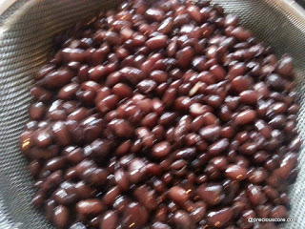](https://www.preciouscore.com/wp-content/uploads/2015/07/Beans2B1-1.jpg)

Chop onions and tomatoes and keep aside.

Warm the oil in a pot and saute the onions.

[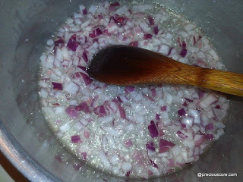](https://www.preciouscore.com/wp-content/uploads/2015/07/Beans2B3-1.jpg)

Add in tomatoes and let it fry. Keep stirring from time to time.

[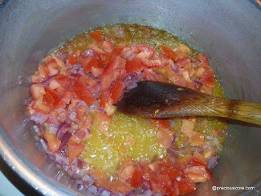](https://www.preciouscore.com/wp-content/uploads/2015/07/Beans2B4-1.jpg)

The tomatoes are ready when they are well shrunk and start sticking to the pot.

[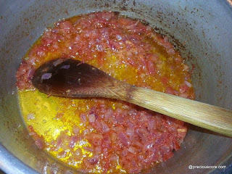](https://www.preciouscore.com/wp-content/uploads/2015/07/Beans2B6-1.jpg)

Add in spring onions and stir. Then add in garlic, ginger and seasoning cubes and stir.

[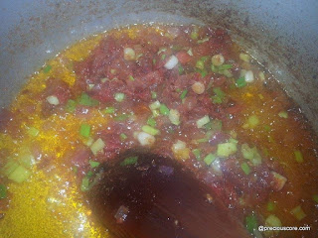](https://www.preciouscore.com/wp-content/uploads/2015/07/Beans2B7-1.jpg)

Add in the boiled beans. Mix well and allow to simmer for a few minutes. Adjust for seasonings. You can add more salt if you wish.

How to Make Water Fufu from Scratch - Cassava Fufu

**Prep Time**

30 mins

**Cook Time**

15 mins

**Total Time**

45 mins

Fufu is a staple in a good number of African countries. This version is made by fermenting cassava (yuca roots) then blending and cooking. It can be enjoyed with any soup of choice.

Course: Main Course

Cuisine: African

Servings: 5 servings

Author: Precious of preciouscore.com

**Ingredients**

* 6 large tubers of cassava (yuca root)
* 2 teaspoons baking soda optional

**Instructions**

1. Peel the cassava. Cut each tuber into 5 or 6 pieces then split each piece in the middle part where you can see  the fibre. Use a knife to lift up the skin from the divided cassava then use your knife or hand to take off the whole skin.
2. Wash the cassava thoroughly and place in a large container. Pour in water to completely cover the cassava then add in two teaspoons of baking soda. Cover the container and keep it to ferment in a warm corner for 3 - 5 days.  To check if the cassava is well fermented, press with your fingers, if it is soft then it is okay. Note that all might not be very soft but if most are soft then you are good to go.

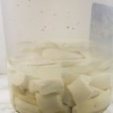

1. Strain the fermented cassava to remove excess water. Then place in a blender or food processor and process into a puree. You may have to do this in two batches.
2. Now remove any fibre you see in the puree. You can do this by either running your hand through the puree and picking out any fibre, or by adding water to the puree then passing it through a strainer. It is recommended that you use you hand if you intend on cooking the fufu right away.
3. Pour the puree into a clean kitchen towel or cheese cloth the squeeze to remove excess water. If you added more water to enable you pass the fufu through a strainer, you may need to squeeze longer. Or tightly tie the kitchen cloth containing the puree and place in the kitchen sink with a heavy object on top to help push out the water. When the excess water is out, your fufu is ready to be cooked!

**To cook the cassava fufu:**

1. Place the raw fufu in a pot then run through it with your hands to dissolve any excess lumps. Add a quarter cup of water and mix to form a paste.
2. Place on medium high heat then cover and let it rest for two minutes. Begin stirring with a wooden spoon, mixing hard enough to dissolve the lumps that form as it cooks.
3. Add water as needed (about 1 cup in total) while stirring to ensure that the fufu is not too strong. Please [see video](https://www.youtube.com/watch?v=2K-FFs4R0as&feature=youtu.be) to see how the texture should be. Keep mixing on heat until the fufu moves from being bright white to an off-white colour. It is ready when it is an off-white colour.
4. Turn off the heat then mold the fufu into lumps (shaped like small logs of wood or like balls) if you wish.
5. Enjoy with any soup of choice! I love enjoying it with[eru](https://www.preciouscore.com/the-best-eru-recipe-ever/) or [ogbono soup](https://www.preciouscore.com/ogbono-and-egusi-soup-soup-of-the-year/" \t "_blank).

**Recipe Notes**

1. The baking soda in this recipe helps initiate the fermentation process. This is important if you purchase your cassava outside Africa.

Here is all you need for this super simple soup:

About 15 medium sized okras, 2 Maggi cubes, a quarter cup of crayfish, 1 large cleaned tilapia fish, half a medium-sized onion and a handful of spinach.

Chop the okra into circles.

Then chop finely. This chopping process is therapeutic for me but if you find it worrisome, just grate the okras or cut roughly and pulse in a blender.

Cut tilapia fish and place in a pot with about four cups of water. Chop onions and add on top. Season with salt.

Bring that to boil on medium heat. Then put in chopped okra, crayfish and Maggi. If you are in love with pepper, add it in.

Chop spinach and set aside. Let it boil! Let it boo-oo-ooil. But not too much so you don’t loose the green colour and the nutrients. Add in the chopped spinach.

Then QUICKLY turn off your heat. There you have it! Delicious, healthy, super simple okra soup.

Cameroon Banana Cake Recipe

**Prep Time**

10 mins

**Cook Time**

20 mins

**Total Time**

30 mins

This is Cameroon Banana cake as I enjoyed while growing up. It is great for snacking, breakfast, parties or for entertaining guests. It is also a great way to use up overripe bananas. Hope you enjoy this recipe!

Course: Snack

Cuisine: Cameroonian

Servings: 12 cupcakes

Calories: 145 kcal

Author: Precious Nkeih of preciouscore.com

**Ingredients**

* 2 large bananas or 3 small bananas
* 1 1/2 cups flour
* 1/4 cup of vegetable oil
* 2 large eggs
* 1/4 cup sugar
* 1/2 teaspoon baking soda
* 1/2 teaspoon baking powder
* 1/2 teaspoon cinnamon powder or nutmeg optional
* A pinch of salt

**Instructions**

1. Prepare your baking tins by greasing or by lining with cupcake liners then set your oven to 350 Degrees Fahrenheit (About 176 Degrees Celsius).
2. Peel your dejected bananas and dump in a blender. Add in some water (about a quarter cup) and blend. If you are feeling like an Ajebota, use liquid milk to blend instead of water. Put that in your mixing bowl. It is the one and only mixing bowl you will need for this recipe. Praise the Lord.
3. Now crack open your eggs and dump in.
4. Pour in the vegetable oil. Give that a really good mix.
5. Now my friend, throw in flour, sugar, salt, baking powder and baking soda. Now mix until everything is in harmony.
6. Fill your prepared baking tin with the batter trying to make sure each cup has about the same amount of batter fill each to about 2/3rd.
7. Now top each of them with a few shakes of cinnamon powder. Please note that this is totally optional. Use a spoon to lightly swirl the cinnamon. Don't mix it. Just turn it in a little so it looks more appealing.

Alternately add half a teaspoon of ground nutmeg when adding the flour and other dry ingredients.

1. Bake in the preheated oven for about 20 minutes or until a toothpick inserted in one of the cakes comes out clean.

Cameroonian Soya

**Prep Time**

10 mins

**Cook Time**

20 mins

**Total Time**

30 mins

Soya is beef that is marinated is spices and threaded on skewers then grilled.

Course: Appetizer

Cuisine: African

Servings: 4 people

Calories: 166 kcal

Author: Precious Nkeih

**Ingredients**

* 1 pound beef - top sirloin steak (about half kg)
* 2 tablespoons vegetable oil
* 4 garlic cloves- grated
* 1/2 inch ginger root - grated
* 1 small seasoning cube- Maggi
* 1/4 teaspoon salt
* 1/8 teaspoon cayenne pepper
* 1/8 teaspoon white pepper

**Instructions**

1. If using wooden skewers, soak in water for 30 minutes before using.

To make the marinade: In a bowl, mix together all ingredients except the meat. Set aside.

1. Cut meat into thin slices (please see video).
2. Mix together the meat and the marinade making sure the marinade gets to every part of the meat. Cover and let it rest for 30 minutes.
3. Preheat oven to 400 degrees F.  Thread the meat on skewers.
4. Place on a baking tray lined with aluminum foil and place in the pre-heated oven to cook for about 15-20 minutes. Half way through, turn skewers to the other side. This means one side will cook for about 7-10 minutes.

However, if you cut your meat a lot thinner than mine (as seen in the video) one side will cook for only about 5 minutes. It gets ready in no time! Avoid leaving the meat too long in the oven because it could become tough and hard to chew.

1. Remove, allow to rest and enjoy with some [pepper sauce](https://www.preciouscore.com/how-to-make-delicious-pepper-sauce/). You could also serve this with some roasted plantains.

# DELICIOUS CAMEROON FRIED CHICKEN

**Ingredients needed:**

2 pounds (or 1 kg) of chicken part of choice (or whole chicken)

5 cloves of garlic

Half an inch of ginger root

2 stems of herbs – 1 celery and 1 parsely

1 medium-sized onion

Half a teaspoon of white pepper

2 seasoning cubes (maggi)

Half a teaspoon of salt

Vegetable oil for frying

Wash your chicken, cut into desired pieces and dump in a pot:

Blend together spices, onion, green herbs and pour over chicken,

Season with salt and maggi and bring to a boil.

Now heat up oil in another pot. Then remove chicken from stock and fry in heated oil.

It is ready when the chicken is brown all around. Easy, isn’t it?

**Fruit Salad Recipe**

*Prep: 20 mins*  
*No cooking required*  
*Serves: 4*

**Ingredients**  
1 pineapple  
1 paw paw (papaya)  
2 firm ripe mangoes  
1 large apple  
1 small watermelon or half of a large one

**Corn Chaff Recipe**

**[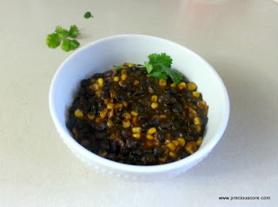](https://4.bp.blogspot.com/-8t6y_TBqIPU/VzyST6C5dUI/AAAAAAAAEgM/R6n8cT7E-0Ax3r0XXSuE_pEAEBGWGXg5gCLcB/s1600/how%2Bto%2Bmake%2Bdelicious%2Bcornchaff.jpg)**

*Prep: 15 mins*

*Cook: 2 hrs*

*Total: 2 hrs 15 mins*

**Ingredients**

2 cups of dried beans

2 cups of dried corn (or 4 cups of pre-cooked corn: sweet corn)

1 medium sized onion

4 stems of green spices: parsley, celery (2 of each)

1 stem of green onions (or leeks)

5 cloves of garlic

Half an inch of ginger

1 cup of palm oil (or more if you are an oil freak)

3 seasoning cubes (maggi, knorr, etc)or two teaspoons of bouillon seasoning powder

Half a cup of crayfish (optional)

1 habanero pepper

**Directions**

1. Boil your corn (if using dried) till it is soft. If you are using canned corn or frozen like I used here,  just go ahead and boil the beans till it is really soft. You do not want it hard.

2. Rinse out your corn if canned or frozen and set aside.

3. Rinse out your beans then combine corn and bring in a pot with a cup of water and set on medium heat.

4. Now prepare all your spices: ginger, garlic, onions, herbs, etc. Blend them together and dump into the pot.

5. Add in salt, maggi and the palm oil. Yes, yes, yes!!!

6. Let all that goodness simmer together for about 20 minutes. Let the aroma fill your house. Let your taste buds dance for joy. *Corn Chaff don done!*

Hot Potatoes(African Stewed Potatoes)

**Prep Time**

10 mins

**Cook Time**

25 mins

**Total Time**

35 mins

Servings:  -5

Calories: 497 kcal

Author: AfricanBites

**Ingredients**

* 2.5 pounds russet potatoes
* .5 cup canola oil
* 1.5 pound chicken
* 1 medium onion
* 4 tomatoes chopped
* 1 teaspoons granulated garlic
* 1 teaspoon [smoked paprika](https://www.amazon.com/gp/product/B00D62GFOE/ref=as_li_qf_sp_asin_il_tl?ie=UTF8&tag=josfav-20&camp=1789&creative=9325&linkCode=as2&creativeASIN=B00D62GFOE&linkId=322ffbeb0299275daab2f7547f491c10" \t "_blank)
* 1- teaspoon white pepper
* 1 scotch bonnet pepper optional
* 1 teaspoon Chicken bouillon optional
* 1 medium bell pepper green or red chopped
* 1 cup sliced carrots
* Salt to taste
* 2 cups water or chicken broth

**Instructions**

1. Peel potatoes and cut into big chunks. Place in water to prevent discoloration
2. Heat canola oil in a medium saucepan over medium heat until hot.
3. Add the smoked turkey sauté with onions in the oil for 3-4 minutes, stirring often and scraping any browned bits off the bottom of the pot.
4. Add tomatoes, cayenne pepper, paprika, Maggie (bouillon) and cook stirring for about 5-7 minutes
5. Through in the potatoes, water and let it simmer, for about 5-7 minutes,then add carrots , bell pepper continue cooking until potatoes are tender. You may have to stir occasionally to prevent burns.
6. Adjust for seasonings and serve

African Grill Chicken (kati kati)

African Grill Chicken (kati kati) - grilled chicken, then sauteed to perfect with the right blend of spices to give you a lip-smacking chicken dish!

Course: Main

Cuisine: African

Servings:  -9 pieces

Calories: 185 kcal

Author: Immaculate Bites

**Ingredients**

* 3-4 pounds of chicken skin- on cut up into desired pieces
* 1 ¼ teaspoon salt
* 1 tablespoon onion powder
* 1 ½ tablespoon garlic powder
* 1 teaspoon white pepper
* ½ teaspoon cayenne pepper
* 1 teaspoon bouillon powder , you may replace with salt
* Sauce
* 2 fresh tomatoes
* ½ cup water or more as needed
* Chicken bouillon to taste

**Instructions**

1. Trim chicken of excess fat and pat dry with a cloth or paper napkin.
2. In a small bowl combine the spices, onions, pepper, garlic, and Maggie.
3. Season chicken with spice rub.
4. Preheat a hot barbecue, grill, griddle or frying pan.
5. Place chicken on the grill coated with cooking spray; grill for about 20~30 minutes, rotating sides or until browned and almost cooked.
6. Blend tomatoes and set aside.
7. Heat up a large saucepan over medium heat –add palm oil to the pan and tomatoes puree. Sauté for about 4-5 minutes, stirring occasionally
8. Transfer the chicken to the saucepan and bring to a simmer over low heat, spooning the sauce over the chicken to coat.
9. Add about 1/2-1cup of water cover and cook until the chicken is well flavored by the sauce 4 to 5 minutes and thoroughly cooked through. Adjust for seasonings and oil
10. Remove from the heat and serve warm with fufu and njama njama.

African Meat Pie (Beef Empanada)

**Prep Time**

1 hr

**Cook Time**

1 hr

**Total Time**

2 hrs

African style empanadas - slightly sweet , flaky and crusty with a succulent filling.

Course: Appetizer

Cuisine: African

Servings:

Calories: 365 kcal

Author: AfricanBites

**Ingredients**

* 4 cups flour (plus more for dusting)
* 2 Tablespoon sugar
* ½ Tablespoon salt
* 8 oz (228 gram) or 1 cup butter
* 1 egg
* 3/4 cup milk

**Meat Filling**

* 2 tablespoon canola oil
* ½ pound ground meat
* ½ medium onion chopped
* 1 teaspoon minced garlic
* 1 teaspoon chicken bouillon powder (optional)
* ½ cup tomato sauce
* 1 tablespoon [smoked paprika](https://www.amazon.com/gp/product/B00D62GFOE/ref=as_li_qf_sp_asin_il_tl?ie=UTF8&tag=josfav-20&camp=1789&creative=9325&linkCode=as2&creativeASIN=B00D62GFOE&linkId=322ffbeb0299275daab2f7547f491c10" \t "_blank)
* 2 green onion chopped
* 2 tablespoons parsley
* 1 teaspoon white pepper
* salt to taste
* 2 boil eggs (optional)

**Instructions**

1. In a food processor or by hand, mix together salt, sugar ,butter blend well Add the egg, milk in small amounts, pulse until combined and dough holds together in a soft ball.
2. Place the dough on a well floured surface . Divide it into 2 and roll it out .
3. Using a large mouth, glass glass or bowl about 4 - 5 " cut out circles by gently pressing on the dough and releasing it, shaping the meat pie dough. Continue cutting out dough until all dough has been cut. Refrigerate for at least 30 minutes or until ready to use.

**Make the Meat pie filling**

1. Add 2 tablespoon of oil to a sauce pan, followed by onions, garlic, chicken bouillon tomato sauce and paprika . Let it simmer for about 10 minutes, stirring frequently to prevent burning, add about ½ cup of water if needed.
2. Then, add ground meat and continue cooking for about 10 or more minutes.
3. Finally add green onions and parsley, white pepper. Followed by salt to  taste  Adjust seasonings to taste .
4. Remove from stove top and let it cool.

**Assembling Meat pie**

1. Scoop a heaping tablespoon of filling into each circle, top with egg and brush the egg white around half of the circle. Fold over twist and and press with fingers gently to seal the edges of the meat pie.
2. Another way of sealing is by pressing the tines of a fork along the edges of the dough.
3. Carefully place each meat pie  on a baking sheet  or you may freeze to use later.
4. Set oven temperature to 350 degrees .Bake for about 30 minutes .

Kondres

**Prep Time**

20 mins

**Cook Time**

2 hrs

**Total Time**

2 hrs 20 mins

Kondres (Spicy Stewed Plantains) - popular Cameroonian one-pot meal with highly-seasoned spicy stewed plantains, meat and veggies. Exotic, spicy and mouth-watering!

Course: Main

Cuisine: African

Servings:  -5

Calories: 866 kcal

Author: Immaculate Bites

**Ingredients**

* 2-3 pounds boil meat cup up beef, oxtail, goat meat, chicken, pork
* 3- 4 pounds unripe or green plantains
* Njansa – 10
* 1 large onion
* 3 large tomatoes
* ¼ cup parsley
* ½ cup basil
* ¼ cup celery leaves
* 2 teaspoons grated ginger
* 8 cloves garlic
* 2 green onions
* 1 teaspoon white pepper
* ½ teaspoon [curry powder](https://www.africanbites.com/jamaican-curry-powder/)
* 1 tablespoon thyme
* 2 bebe optional
* ½ teaspoon country onion optional
* ½ - 1 cup vegetable oil
* 1 tablespoon bouillon powder or 2 Maggi cubes
* Salt to taste

**Instructions**

1. In Large saucepan boil meat seasoned with salt, and, onions until tender depending on the meat with plenty of water for stock. You can shorten this process in half by using a pressure cooker. Reserve stock
2. Using a sharp knife cut both ends off the plantain. This will make it easy to grab the skin of the plantains. Slit a shallow line down the long seam of the plantain; peel only as deep as the peel. Remove plantain peel by pulling it back
3. Cut the plantains into 2-3 pieces depending on size
4. Chop the tomatoes, onions, green onions and place in a food processor or blender- add njansa, peeled pebe, garlic, basil, parsley, celery with a little bit of water -if using a blender to facilitate blending. Blend until puree.
5. Heat up a large pot with oil, then add the tomatoes mixture, white pepper, curry, and meat with meat stock, bring to a boil. Simmer for about 10 minutes stirring occasionally.
6. Then add plantains, Maggi and/or stock / water (enough to cover the plantains)
7. Bring to a boil then reduce heat and let it cook until the plantains is super tender about an hour or more. Add water as necessary to prevent burns.
8. Adjust seasonings to taste.
9. Serve warm.